Project Design Phase-II
Technology Stack (Architecture & Stack)
Date | 12 February 2026
Team ID | LTVIP2026TMIDS82118
Project Name | Exploratory Analysis of Rainfall Data in India for Agriculture
Maximum Marks | 4 Marks

Technical Architecture
Architecture includes UI, Flask backend, preprocessing pipeline, ML model interface, data storage, and optional external APIs. Deployment can be Local initially with cloud-ready design.
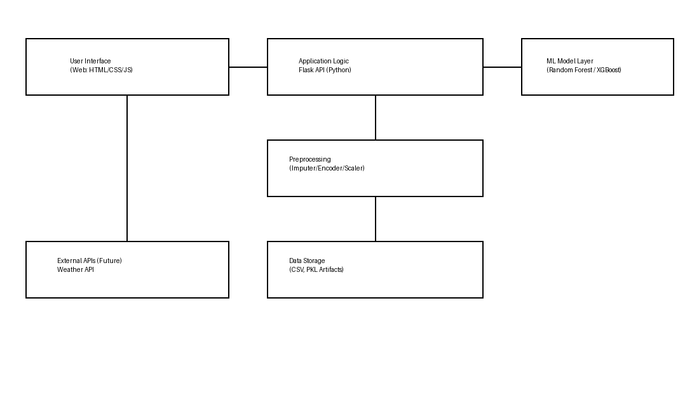

Table-1: Components & Technologies
S.No | Component | Description | Technology
1 | User Interface | User inputs & result visualization (Web UI) | HTML, CSS, JavaScript
2 | Application Logic | API endpoints, routing, validation | Python (Flask)
3 | Preprocessing | Imputation, encoding, scaling | scikit-learn, pandas
4 | Machine Learning Model | Rainfall prediction | Random Forest / XGBoost
5 | Database / Storage | Datasets & artifacts | Local FS (CSV, PKL)
6 | Cloud Storage (Future) | Artifact storage & backups | AWS S3 / GCP Storage (Future)
7 | External API (Future) | Weather data enrichment | OpenWeather API (Optional)
8 | Infrastructure | Local deployment; cloud-ready | Localhost, Docker (Future), Cloud VM/K8s

Table-2: Application Characteristics
S.No | Characteristics | Description | Technology
1 | Open-Source Frameworks | Open-source ML & web stack | Flask, scikit-learn, pandas, NumPy
2 | Security Implementations | Input validation, safe model loading | Flask validation, basic auth (future)
3 | Scalable Architecture | Modular layers; cloud-ready | 3-tier design; Docker/K8s (future)
4 | Availability | Local uptime; cloud HA future | VMs, Load balancer (future)
5 | Performance | Low-latency inference | Caching (future), optimized pipelines

